CNN Transfer learning

What Is Transfer Learning?
Transfer learning in machine learning refers to reusing a pre-trained model on a new problem. A machine uses the knowledge learned from a prior assignment to increase prediction about a new task in transfer learning. You could, for example, use the information gained during training to distinguish beverages when training a classifier to predict whether an image contains cuisine.
During transfer learning, a trained machine learning model transfers its knowledge to a different but closely linked problem to improve performance. For example, if you trained a simple classifier to predict whether an image contains a backpack, you could use the model’s training knowledge to identify other objects such as sunglasses.
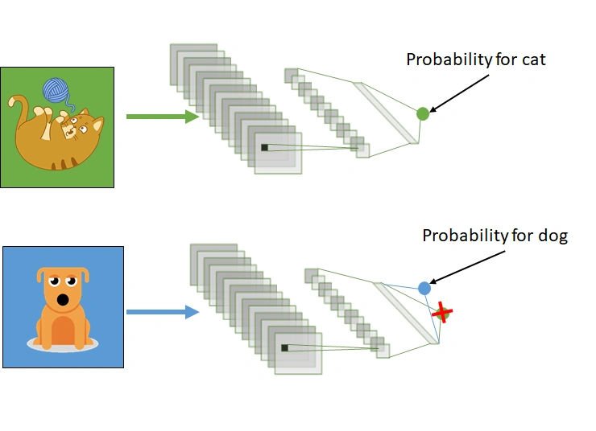
Transfer learning involves using knowledge gained from one task to enhance understanding in another. It automatically shifts weights from a network that performed task B to a network performing task A.
Due to the substantial CPU power demand, practitioners typically apply transfer learning in tasks such as computer vision and natural language processing, such as sentiment analysis.
How Transfer Learning Works?
In computer vision, neural networks typically aim to detect edges in the first layer, forms in the middle layer, and task-specific features in the latter layers.
In transfer learning in CNN, we utilize the early and central layers, while only retraining the latter layers. The model leverages labeled data from its original training task.
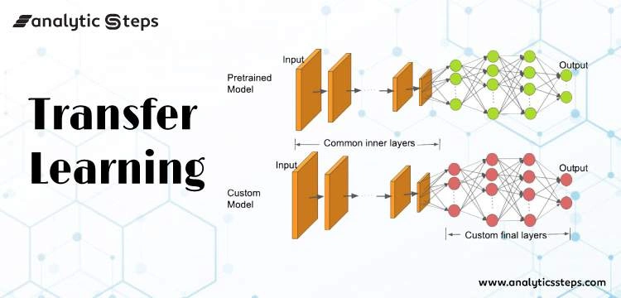
In our example, if a model originally trained to identify backpacks in images now needs to detect sunglasses, it uses its prior learning. Retraining the upper layers allows the model to distinguish sunglasses from other objects using recognized features.
Why Should You Use Transfer Learning?
Transfer learning provides several advantages, including decreased training time, enhanced neural network performance (in many cases), and the ability to work effectively with limited data.
Training a neural model from the ground up usually requires substantial data, which may not always be available. Transfer learning in CNN addresses this challenge effectively.
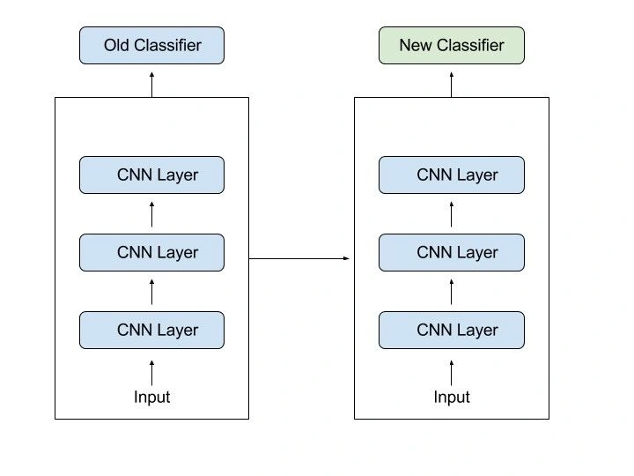
Transfer learning in CNN leverages pre-trained models to achieve strong performance with limited training data, crucial in fields like natural language processing with vast labeled datasets. It reduces training time significantly compared to building complex models from scratch, which can take days or weeks.
Steps to Use Transfer Learning
When annotated data is insufficient for training, leveraging a pre-trained model from TensorFlow trained on similar tasks is beneficial. Restoring the model and retraining specific layers allows adaptation to your task. Transfer learning in deep learning relies on general features learned in the initial task, applicable to new tasks. Ensure the model’s input size matches the original training conditions for effective transfer.
If you don’t have it, add a step to resize your input to the required size:
Training a Model to Reuse it
If you lack data for training Task A with a deep neural network, consider finding a related Task B with ample data. Train your deep neural network on Task B and transfer the learned model to solve Task A. Depending on your problem, you may use the entire model or specific layers. For consistent inputs, you can reuse the model for predictions. Alternatively, adjust and retrain task-specific layers and the output layer as needed.
Using a Pre Trained Model
The second option is to employ a model that has already been trained. There are a number of these models out there, so do some research beforehand. You determine the number of layers to reuse and retrain based on the task.
Keras consists of nine pre-trained models used in transfer learning, prediction, fine-tuning. You can find these models and some quick lessons on how to utilize them here. Many research institutions also make trained models accessible.
The most popular application of this form of transfer learning is deep learning.
Extraction of Features
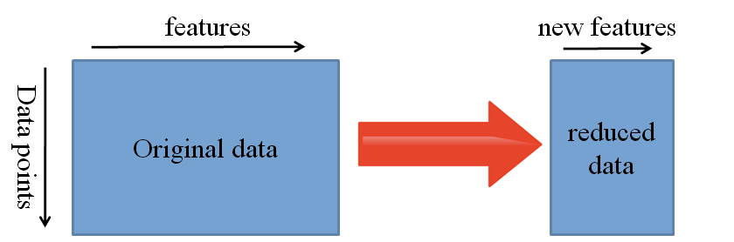
Extraction of Features in Neural Networks
Neural networks can learn which features are important and which are not. For complex tasks that require much human effort, a representation learning algorithm can quickly find a good combination of features.
The learned representation can then apply to a variety of other challenges.
Use the initial layers for feature representation, excluding the network’s task-specific output. Instead, pass data through an intermediate layer to interpret raw data as its representation. This approach is popular in computer vision for dataset reduction and efficiency with traditional algorithms.
Models That Have Been Pre-Trained
One of the popular pre-trained machine learning models available is the Inception-v3 model, developed for the ImageNet “Large Visual Recognition Challenge.” Participants in this challenge had to categorize pictures into 1,000 subcategories such as “zebra,” “Dalmatian,” and “dishwasher.”
Code Implementation of Transfer Learning with Python
Importing Libraries
import tensorflow as tf
import pandas as pd
import matplotlib.pyplot as plt
from tensorflow.keras import Model
from tensorflow.keras.layers import Conv2D, Dense, MaxPooling2D, Dropout, Flatten,GlobalAveragePooling2D
from tensorflow.keras.models import Sequential
from tensorflow.keras.preprocessing.image import ImageDataGenerator
from tensorflow.keras.callbacks import ReduceLROnPlateau
from tensorflow.keras.layers import Input, Lambda, Dense, Flatten
from tensorflow.keras.models import Model
from tensorflow.keras.applications.inception_v3 import InceptionV3
from tensorflow.keras.applications.inception_v3 import preprocess_input
from tensorflow.keras.preprocessing import image
from tensorflow.keras.preprocessing.image import ImageDataGenerator,load_img
from tensorflow.keras.models import Sequential
import numpy as np
from glob import glob
Uploading Data via Kaggle API
from google.colab import files
files.upload()
Saving kaggle.json to kaggle.json
!mkdir -p ~/.kaggle
!cp kaggle.json ~/.kaggle/

!chmod 600 ~/.kaggle/kaggle.json
!kaggle datasets download -d mohamedhanyyy/chest-ctscan-images #downloading data from kaggle API of Dataset
from zipfile import ZipFile
file_name = "chest-ctscan-images.zip"

with ZipFile(file_name,'r') as zip:
zip.extractall()
print('Done')
Designing Our CNN Model with Help of Pre–Trained Model
InceptionV3_model = tf.keras.applications.InceptionV3(weights='imagenet', include_top=False, input_shape=(224, 224, 3))
from tensorflow.keras import Model
from tensorflow.keras.layers import Conv2D, Dense, MaxPooling2D, Dropout, Flatten,GlobalAveragePooling2D
from tensorflow.keras.models import Sequential

# The last 15 layers fine tune
for layer in InceptionV3_model.layers[:-15]:
layer.trainable = False

x = InceptionV3_model.output
x = GlobalAveragePooling2D()(x)
x = Flatten()(x)
x = Dense(units=512, activation='relu')(x)
x = Dropout(0.3)(x)
x = Dense(units=512, activation='relu')(x)
x = Dropout(0.3)(x)
output = Dense(units=4, activation='softmax')(x)
model = Model(InceptionV3_model.input, output)
model.summary()
Image Augmentation( For Preventing the Issue of Overfitting)
# Use the Image Data Generator to import the images from the dataset
from tensorflow.keras.preprocessing.image import ImageDataGenerator

train_datagen = ImageDataGenerator(rescale = 1./255,
shear_range = 0.2,
zoom_range = 0.2,
horizontal_flip = True)

test_datagen = ImageDataGenerator(rescale = 1./255)
#no flip and zoom for test datase
# Make sure you provide the same target size as initialied for the image size
training_set = train_datagen.flow_from_directory('/content/Data/train',
target_size = (224, 224),
batch_size = 32,
class_mode = 'categorical')
Training Our Model
# fit the model
# Run the cell. It will take some time to execute
r = model.fit_generator(
training_set,
validation_data=test_set,
epochs=8,
steps_per_epoch=len(training_set),
validation_steps=len(test_set)
)
# plot the loss
plt.plot(r.history['loss'], label='train loss')
plt.plot(r.history['val_loss'], label='val loss')
plt.legend()
plt.show()
plt.savefig('LossVal_loss')

# plot the accuracy
plt.plot(r.history['accuracy'], label='train acc')
plt.plot(r.history['val_accuracy'], label='val acc')
plt.legend()
plt.show()
plt.savefig('AccVal_acc')
Making Predictions
import numpy as np
y_pred = np.argmax(y_pred, axis=1)
y_pred
The above code executes and shows the respective output for classification using transfer learning in deep learning below the embedded notebook.
Source: Loss

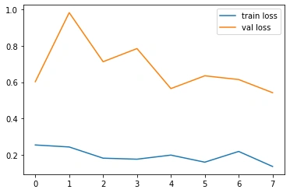
plotSource: Accuracy Plot
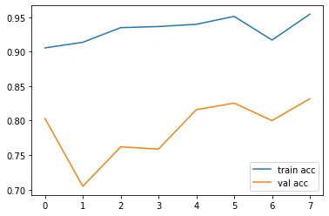

You can access the Github link for Google Colab notebook here!

Feature Extraction
In the realm of Transfer Learning, the debate of feature extraction vs fine tuning centers on how we utilize pre-trained models.
Feature Extraction involves using a pre-trained model as a fixed feature extractor, where the learned representations are used to extract meaningful features from new data without modifying the pre-trained weights.
How It Works
- Pre-Trained Model: start with a model trained on a large dataset like ImageNet;
- Freeze Layers: keep all layers of the pre-trained model frozen; their weights are not updated during training;
- Add New Layers: attach new output layers tailored to the specific task, which are trained from scratch using the features extracted by the pre-trained model.
Real-World Applications
- Medical Imaging: utilizing pre-trained models to detect anomalies in medical scans when labeled data is limited;
- Environmental Monitoring: analyzing satellite images for tasks like deforestation detection with scarce labeled data;
- Text Classification: applying pre-trained language models for sentiment analysis or topic classification with small datasets.
Keras Code Example
from tensorflow.keras.applications import VGG16
from tensorflow.keras.layers import Dense, GlobalAveragePooling2D
from tensorflow.keras.models import Model

# Load the pre-trained model
base_model = VGG16(weights='imagenet', include_top=False)

# Freeze the base model
base_model.trainable = False

# Add new layers on top
x = base_model.output
x = GlobalAveragePooling2D()(x)
x = Dense(1024, activation='relu')(x)
predictions = Dense(num_classes, activation='softmax')(x)

# Define the new model
model = Model(inputs=base_model.input, outputs=predictions)

# Compile the model
model.compile(optimizer='adam', loss='categorical_crossentropy', metrics=['accuracy'])

# Train the model on new data
model.fit(new_data, new_labels, epochs=10, batch_size=32)
Fine Tuning
Fine Tuning extends Transfer Learning by not only adding new layers but also retraining some of the pre-trained layers. This approach adjusts the model's weights to be more relevant to the new task, making ml fine tuning a powerful technique for achieving higher performance when sufficient data is available.
How It Works
- Pre-Trained Model: begin with a model trained on a large dataset;
- Unfreeze Some Layers: unfreeze a portion of the pre-trained layers so their weights can be updated during training;
- Retrain Model: train both the unfrozen pre-trained layers and the new layers on the new dataset.
Keras Code Example
from tensorflow.keras.applications import VGG16
from tensorflow.keras.layers import Dense, GlobalAveragePooling2D
from tensorflow.keras.models import Model
from tensorflow.keras.optimizers import Adam

# Load the pre-trained model
base_model = VGG16(weights='imagenet', include_top=False)

# Unfreeze the top layers of the model
base_model.trainable = True
for layer in base_model.layers[:-4]:
layer.trainable = False

# Add new layers on top
x = base_model.output
x = GlobalAveragePooling2D()(x)
x = Dense(1024, activation='relu')(x)
predictions = Dense(num_classes, activation='softmax')(x)

# Define the new model
model = Model(inputs=base_model.input, outputs=predictions)

# Compile the model with a lower learning rate
model.compile(optimizer=Adam(learning_rate=1e-5), loss='categorical_crossentropy', metrics=['accuracy'])

# Train the model on new data
model.fit(new_data, new_labels, epochs=10, batch_size=32)
In ML fine tuning, we unfreeze the last few layers of the pre-trained model (e.g., the last four layers in VGG16) to allow their weights to be updated during training.
This helps the model adjust its learned features to better suit the new task. A lower learning rate is used to prevent large updates to the weights, preserving the valuable features learned previously.
Comparison of Feature Extraction and Fine Tuning
Understanding the differences between fine tuning vs feature extraction is essential for selecting the appropriate approach for your machine learning project.

Feature Extraction Pros
- Less Data Required: effective with smaller datasets.
- Reduced Overfitting Risk: fewer trainable parameters lower the chance of overfitting.
- Lower Computational Cost: faster training times and less resource-intensive.
- Simplicity: easier to implement and fine-tune.
Feature Extraction Cons
- Limited Adaptability: cannot adjust pre-trained features to fit new, unique aspects of the data.
- Potential Lower Performance: may not achieve optimal results if the new task significantly differs from the original.

Feature Extraction Pros
- Improved Performance: adjusts pre-trained features for better accuracy on the new task.
- Adaptability: better suits the specifics of the new dataset.
- Flexibility: control over which layers to retrain allows for customization.
Feature Extraction Cons
- More Data Required: needs a larger dataset to prevent overfitting.
- Higher Computational Cost: longer training times and more resources needed.
- Complexity: requires careful tuning of hyperparameters and learning rates.

While Transfer Learning is the overarching concept of utilizing a pre-trained model for a new task, Fine Tuning is a specific method within this framework. Understanding the difference between fine tuning and transfer learning is key to effectively applying these techniques.
- Transfer Learning: the general approach of leveraging a pre-trained model for a different but related task.
- Feature Extraction: a Transfer Learning method where the pre-trained model's layers are kept frozen, and only new layers are trained.
- Fine Tuning: a Transfer Learning method where some of the pre-trained model's layers are unfrozen and retrained along with new layers.
In essence, Fine Tuning is a type of Transfer Learning that allows for more adaptation to the new task by updating some of the pre-trained model's parameters.

What is Transfer Learning?
Let us start with developing an intuition for transfer learning. Let us understand from a simple teacher – student analogy.
A teacher has years of experience in the particular topic they teach. With all this accumulated information, the lectures that students get is a concise and brief overview of the topic. So it can be seen as a “transfer” of information from the learned to a novice.
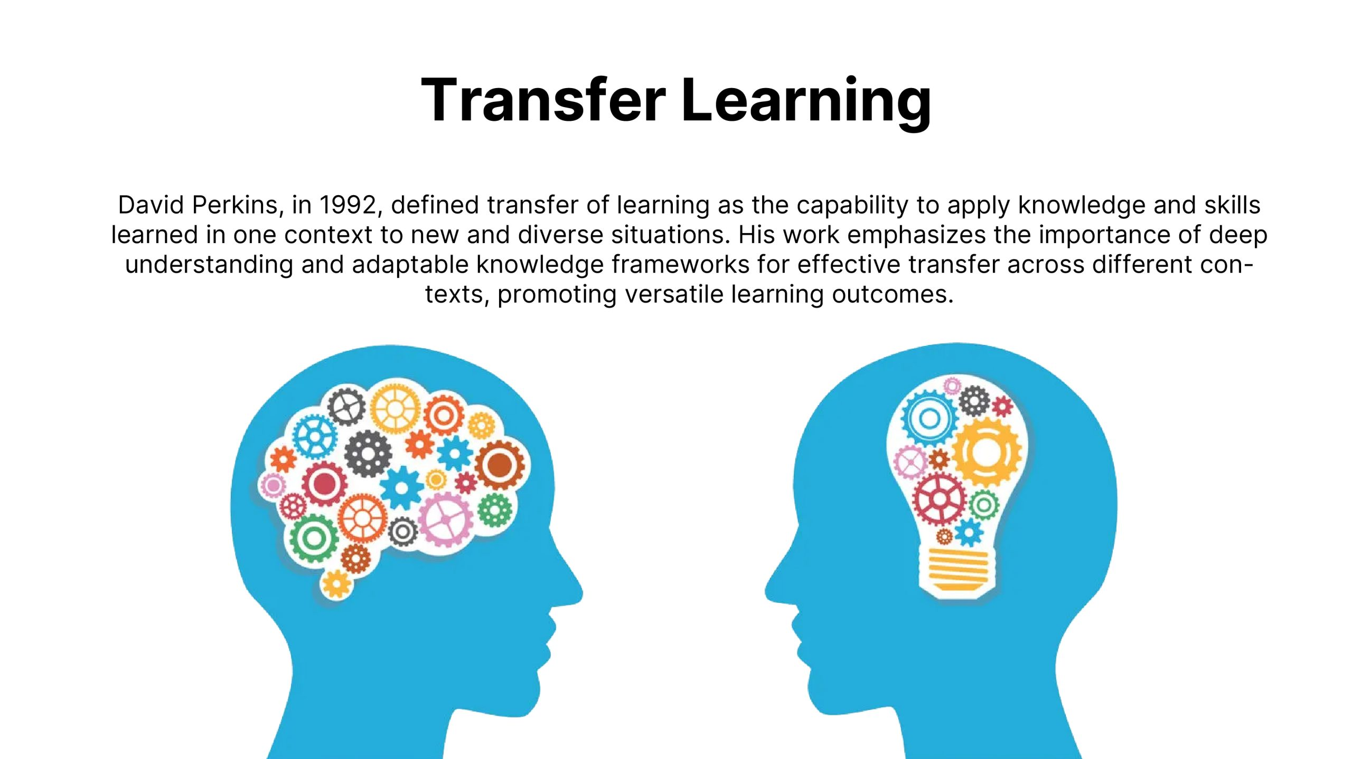
Keeping in mind this analogy, we compare this to neural network. A neural network is trained on a data. This network gains knowledge from this data, which is compiled as “weights” of the network. These weights can be extracted and then transferred to any other neural network. Instead of training the other neural network from scratch, we “transfer” the learned features.
Now, let us reflect on the importance of transfer learning by relating to our evolution. And what better way than to use transfer learning for this! So I am picking on a concept touched on by Tim Urban from one of his recent articles on waitbutwhy.com
Tim explains that before language was invented, every generation of humans had to re-invent the knowledge for themselves and this is how knowledge growth was happening from one generation to other:
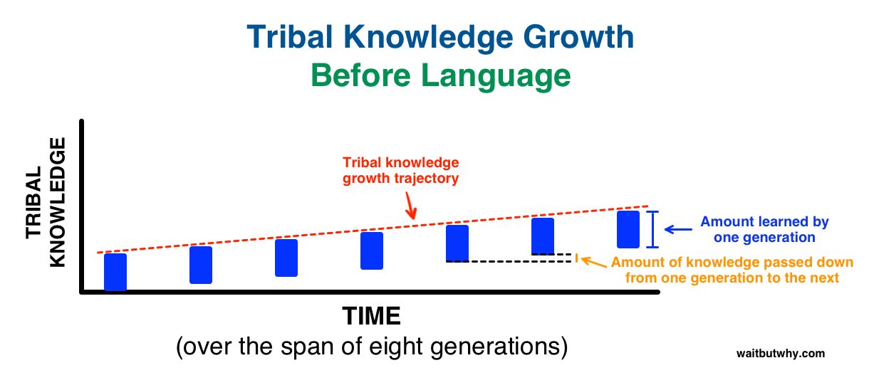
Then, we invented language! A way to transfer learning from one generation to another and this is what happened over same time frame:
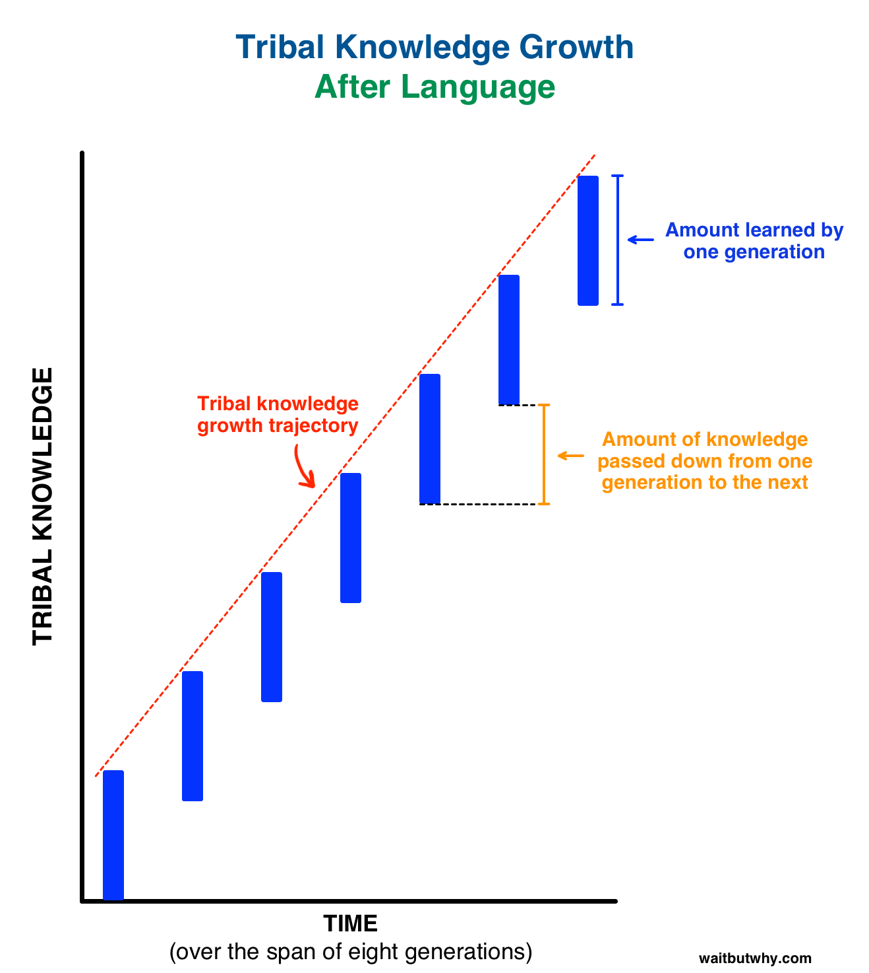
Isn’t it phenomenal and super empowering? So, transfer learning by passing on weights is equivalent of language used to disseminate knowledge over generations in human evolution.
What is a Pre-trained Model?
Simply put, a pre-trained model is a model created by some one else to solve a similar problem. Instead of building a model from scratch to solve a similar problem, you use the model trained on other problem as a starting point.
For example, if you want to build a self learning car. You can spend years to build a decent image recognition algorithm from scratch or you can take inception model (a pre-trained model) from Google which was built on ImageNet data to identify images in those pictures.
A pre-trained model may not be 100% accurate in your application, but it saves huge efforts required to re-invent the wheel. Let me show this to you with a recent example.
Why would we use Pre-trained Models?
I spent my last week working on a problem at CrowdAnalytix platform – Identifying themes from mobile case images. This was an image classification problem where we were given 4591 images in the training dataset and 1200 images in the test dataset. The objective was to classify the images into one of the 16 categories. After the basic pre-processing steps, I started off with a simple MLP model with the following architecture –
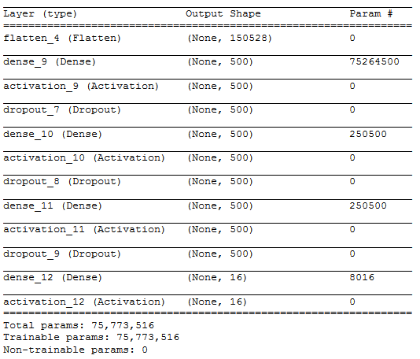
To simplify the above architecture after flattening the input image [224 X 224 X 3] into [150528], I used three hidden layers with 500, 500 and 500 neurons respectively. The output layer had 16 neurons which correspond to the number of categories in which we need to classify the input image.
I barely managed a training accuracy of 6.8 % which turned out to be very bad. Even experimenting with hidden layers, number of neurons in hidden layers and drop out rates. I could not manage to substantially increase my training accuracy. Increasing the hidden layers and the number of neurons, caused 20 seconds to run a single epoch on my Titan X GPU with 12 GB VRAM.
Below is an output of the training using the MLP model with the above architecture.
Epoch 10/10
50/50 [==============================] – 21s – loss: 15.0100 – acc: 0.0688
Transition to CNN Architecture
As, you can see MLP was not going to give me any better results without exponentially increasing my training time. So I switched to Convolutional Neural Network to see how they perform on this dataset and whether I would be able to increase my training accuracy.
The CNN had the below architecture –
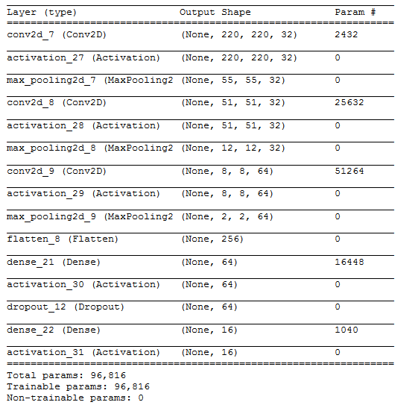
I used 3 convolutional blocks with each block following the below architecture-
- 32 filters of size 5 X 5
- Activation function – relu
- Max pooling layer of size 4 X 4
The result obtained after the final convolutional block was flattened into a size [256] and passed into a single hidden layer of with 64 neurons. The output of the hidden layer was passed onto the output layer after a drop out rate of 0.5.
The result obtained with the above architecture is summarized below-
Epoch 10/10
50/50 [==============================] – 21s – loss: 13.5733 – acc: 0.1575
Though my accuracy increased in comparison to the MLP output, it also increased the time taken to run a single epoch – 21 seconds.
Utilizing Pre-trained VGG16 Model
But the major point to note was that the majority class in the dataset was around 17.6%. So, even if we had predicted the class of every image in the train dataset to be the majority class, we would have performed better than MLP and CNN respectively. Addition of more convolutional blocks substantially increased my training time. This led me to switch onto using pre-trained models where I would not have to train my entire architecture but only a few layers.
So, I used VGG16 model which is pre-trained on the ImageNet dataset and provided in the keras library for use. Below is the architecture of the VGG16 model which I used.
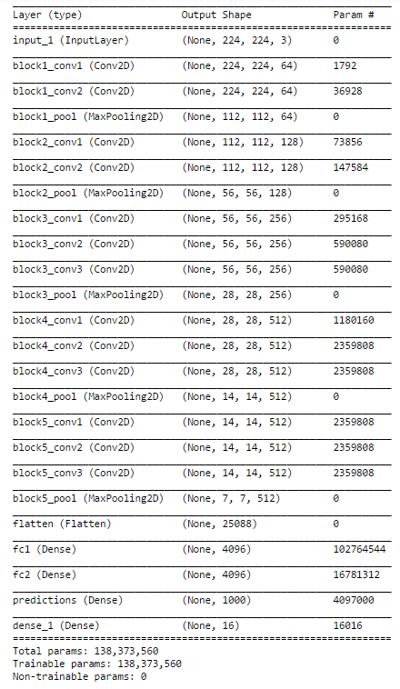
The only change that I made to the VGG16 existing architecture is changing the softmax layer with 1000 outputs to 16 categories suitable for our problem and re-training the dense layer.
This architecture gave me an accuracy of 70% much better than MLP and CNN. Also, the biggest benefit of using the VGG16 pre-trained model was almost negligible time to train the dense layer with greater accuracy.
So, I moved forward with this approach of using a pre-trained model and the next step was to fine tune my VGG16 model to suit this problem.
How to use Pre-trained Models?
What is our objective when we train a neural network? We wish to identify the correct weights for the network by multiple forward and backward iterations. By using pre-trained models which have been previously trained on large datasets, we can directly use the weights and architecture obtained and apply the learning on our problem statement. This is known as transfer learning. We “transfer the learning” of the pre-trained model to our specific problem statement.
You should be very careful while choosing what pre-trained model you should use in your case. If the problem statement we have at hand is very different from the one on which the pre-trained model was trained – the prediction we would get would be very inaccurate. For example, a model previously trained for speech recognition would work horribly if we try to use it to identify objects using it.
We are lucky that many pre-trained architectures are directly available for us in the Keras library. Imagenet data set has been widely used to build various architectures since it is large enough (1.2M images) to create a generalized model. The problem statement is to train a model that can correctly classify the images into 1,000 separate object categories. These 1,000 image categories represent object classes that we come across in our day-to-day lives, such as species of dogs, cats, various household objects, vehicle types etc.
These pre-trained networks demonstrate a strong ability to generalize to images outside the ImageNet dataset via transfer learning. We make modifications in the pre-existing model by fine-tuning the model. Since we assume that the pre-trained network has been trained quite well, we would not want to modify the weights too soon and too much. While modifying we generally use a learning rate smaller than the one used for initially training the model.
Ways to Fine Tune the Model
- Feature extraction – We can use a pre-trained model as a feature extraction mechanism. What we can do is that we can remove the output layer( the one which gives the probabilities for being in each of the 1000 classes) and then use the entire network as a fixed feature extractor for the new data set.
- Use the Architecture of the pre-trained model – What we can do is that we use architecture of the model while we initialize all the weights randomly and train the model according to our dataset again.
- Train some layers while freeze others – Another way to use a pre-trained model is to train is partially. What we can do is we keep the weights of initial layers of the model frozen while we retrain only the higher layers. We can try and test as to how many layers to be frozen and how many to be trained.
The below diagram should help you decide on how to proceed on using the pre trained model in your case –
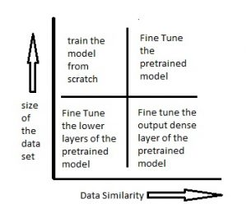
Scenario 1 – Size of the Data set is small while the Data similarity is very high
In this case, since the data similarity is very high, we do not need to retrain the model. All we need to do is to customize and modify the output layers according to our problem statement. We use the pretrained model as a feature extractor. Suppose we decide to use models trained on Imagenet to identify if the new set of images have cats or dogs. Here the images we need to identify would be similar to imagenet, however we just need two categories as my output – cats or dogs. In this case all we do is just modify the dense layers and the final softmax layer to output 2 categories instead of a 1000.
Scenario 2 – Size of the data is small as well as data similarity is very low
In this case we can freeze the initial (let’s say k) layers of the pretrained model and train just the remaining(n-k) layers again. The top layers would then be customized to the new data set. Since the new data set has low similarity it is significant to retrain and customize the higher layers according to the new dataset. The small size of the data set is compensated by the fact that the initial layers are kept pretrained(which have been trained on a large dataset previously) and the weights for those layers are frozen.
Scenario 3 – Size of the data set is large however the Data similarity is very low
In this case, since we have a large dataset, our neural network training would be effective. However, since the data we have is very different as compared to the data used for training our pretrained models. The predictions made using pretrained models would not be effective. Hence, its best to train the neural network from scratch according to your data.
Scenario 4 – Size of the data is large as well as there is high data similarity
This is the ideal situation. In this case the pretrained model should be most effective. The best way to use the model is to retain the architecture of the model and the initial weights of the model. Then we can retrain this model using the weights as initialized in the pre-trained model.
Use the Pre-trained Models to Identify Handwritten Digits
Let’s now try to use a pretrained model for a simple problem. There are various architectures that have been trained on the imageNet data set. You can go through various architectures here. I have used vgg16 as pretrained model architecture and have tried to identify handwritten digits using it. Let’s see in which of the above scenarios would this problem fall into. We have around 60,000 training images of handwritten digits. This data set is definitely small. So the situation would either fall into scenario 1 or scenario 2. We shall try to solve the problem using both these scenarios. The data set can be downloaded from here.
- Retrain the output dense layers only – Here we use vgg16 as a feature extractor. We then use these features and send them to dense layers which are trained according to our data set. The output layer is also replaced with our new softmax layer relevant to our problem. The output layer in a vgg16 is a softmax activation with 1000 categories. We remove this layer and replace it with a softmax layer of 10 categories. We just train the weights of these layers and try to identify the digits.

# importing required libraries from keras.models import Sequential from scipy.misc import imread get_ipython().magic('matplotlib inline') import matplotlib.pyplot as plt import numpy as np import keras from keras.layers
import Dense import pandas as pd from keras.applications.vgg16
import VGG16 from keras.preprocessing
import image from keras.applications.vgg16
import preprocess_input import numpy as np from keras.applications.vgg16
import decode_predictions t
rain=pd.read_csv("R/Data/Train/train.csv") test=pd.read_csv("R/Data/test.csv") train_path="R/Data/Train/Images/train/" test_path="R/Data/Train/Images/test/" from scipy.misc import imresize # preparing the train dataset train_img=[] for i in range(len(train)): temp_img=image.load_img(train_path+train['filename'][i],target_size=(224,224)) temp_img=image.img_to_array(temp_img) train_img.append(temp_img) #converting train images to array and applying mean subtraction processing
train_img=np.array(train_img) train_img=preprocess_input(train_img) # applying the same procedure with the test dataset test_img=[] for i in range(len(test)): temp_img=image.load_img(test_path+test['filename'][i],target_size=(224,224)) temp_img=image.img_to_array(temp_img)
test_img.append(temp_img) test_img=np.array(test_img) test_img=preprocess_input(test_img) # loading VGG16 model weights model = VGG16(weights='imagenet', include_top=False) # Extracting features from the train dataset using the VGG16 pre-trained model features_train=model.predict(train_img) # Extracting features from the train dataset using the VGG16 pre-trained model features_test=model.predict(test_img) # flattening the layers to conform to MLP input train_x=features_train.reshape(49000,25088) # converting target variable to array train_y=np.asarray(train['label']) # performing one-hot encoding for the target variable train_y=pd.get_dummies(train_y) train_y=np.array(train_y) # creating training and validation set from sklearn.model_selection import train_test_split X_train, X_valid, Y_train, Y_valid=train_test_split(train_x,train_y,test_size=0.3, random_state=42) # creating a mlp model from keras.layers import Dense, Activation model=Sequential() model.add(Dense(1000, input_dim=25088, activation='relu',kernel_initializer='uniform')) keras.layers.core.Dropout(0.3, noise_shape=None, seed=None) model.add(Dense(500,input_dim=1000,activation='sigmoid')) keras.layers.core.Dropout(0.4, noise_shape=None, seed=None) model.add(Dense(150,input_dim=500,activation='sigmoid')) keras.layers.core.Dropout(0.2, noise_shape=None, seed=None)
model.add(Dense(units=10)) model.add(Activation('softmax')) model.compile(loss='categorical_crossentropy', optimizer="adam", metrics=['accuracy']) # fitting the model model.fit(X_train, Y_train, epochs=20, batch_size=128,validation_data=(X_valid,Y_valid))

2. Freeze the weights of first few layers – Here what we do is we freeze the weights of the first 8 layers of the vgg16 network, while we retrain the subsequent layers. This is because the first few layers capture universal features like curves and edges that are also relevant to our new problem. We want to keep those weights intact and we will get the network to focus on learning dataset-specific features in the subsequent layers.
Code for freezing the weights of first few layers.
from keras.models import Sequential from scipy.misc import imread get_ipython().magic('matplotlib inline') import matplotlib.pyplot as plt import numpy as np import keras
from keras.layers import Dense import pandas as pd from keras.applications.vgg16 import VGG16 from keras.preprocessing import image from keras.applications.vgg16 import preprocess_input import numpy as np from keras.applications.vgg16
import decode_predictions from keras.utils.np_utils import to_categorical from sklearn.preprocessing import LabelEncoder from keras.models import Sequential from keras.optimizers import SGD from keras.layers
import Input, Dense, Convolution2D, MaxPooling2D, AveragePooling2D, ZeroPadding2D, Dropout, Flatten, merge, Reshape, Activation from sklearn.metrics import log_loss
train=pd.read_csv("R/Data/Train/train.csv") test=pd.read_csv("R/Data/test.csv") train_path="R/Data/Train/Images/train/" test_path="R/Data/Train/Images/test/" from scipy.misc import imresize train_img=[] for i in range(len(train)):
temp_img=image.load_img(train_path+train['filename'][i],target_size=(224,224)) temp_img=image.img_to_array(temp_img) train_img.append(temp_img) train_img=np.array(train_img) train_img=preprocess_input(train_img) test_img=[] for i in range(len(test)): temp_img=image.load_img(test_path+test['filename'][i],target_size=(224,224))
temp_img=image.img_to_array(temp_img) test_img.append(temp_img) test_img=np.array(test_img) test_img=preprocess_input(test_img)
from keras.models
import Model def vgg16_model(img_rows, img_cols, channel=1, num_classes=None): model = VGG16(weights='imagenet', include_top=True)
model.layers.pop()
model.outputs = [model.layers[-1].output] model.layers[-1].outbound_nodes = [] x=Dense(num_classes, activation='softmax')(model.output)
model=Model(model.input,x) #To set the first 8 layers to non-trainable (weights will not be updated)
for layer in model.layers[:8]:
layer.trainable = False # Learning rate is changed to 0.001 sgd = SGD(lr=1e-3, decay=1e-6, momentum=0.9, nesterov=True) model.compile(optimizer=sgd, loss='categorical_crossentropy', metrics=['accuracy']) return model train_y=np.asarray(train['label']) le = LabelEncoder() train_y = le.fit_transform(train_y) train_y=to_categorical(train_y) train_y=np.array(train_y) from sklearn.model_selection import train_test_split X_train, X_valid, Y_train, Y_valid=train_test_split(train_img,train_y,test_size=0.2, random_state=42) # Example to fine-tune on 3000 samples from Cifar10 img_rows, img_cols = 224, 224 # Resolution of inputs channel = 3 num_classes = 10 batch_size = 16 nb_epoch = 10 # Load our model model = vgg16_model(img_rows, img_cols, channel, num_classes) model.summary() # Start Fine-tuning model.fit(X_train, Y_train,batch_size=batch_size,epochs=nb_epoch,shuffle=True,verbose=1,validation_data=(X_valid, Y_valid)) # Make predictions predictions_valid = model.predict(X_valid, batch_size=batch_size, verbose=1) # Cross-entropy loss score score = log_loss(Y_valid, predictions_valid)

Projects
Now, its time to take the plunge and actually play with some other real datasets. So are you ready to take on the challenge? Accelerate your deep learning journey with the following Practice Problems:
- Practice Problem: Identify the Apparels: Identify the type of apparel for given images
- Practice Problem: Identify the Digits: Identify the digit in given images

https://www.analyticsvidhya.com/blog/2020/08/top-4-pre-trained-models-for-image-classification-with-python-code/

What is the Image Classification Model?
Image classification involves recognizing and grouping images into distinct categories or labels according to their content. For instance, a model could categorize pictures as either “cats,” “dogs,” or “cars.” This is achieved through algorithms trained with numerous labeled images, aiding the model in identifying patterns and characteristics.
Also, With that, we will also be explaining four pre-trained models used for image classification.
Setting Up the System
Since we started with cats and dogs, let us use the Cat and Dog images dataset. The original training dataset on Kaggle has 25000 images of cats and dogs, and the test dataset has 10000 unlabelled images. I have taken a much smaller dataset since we only aim to understand these models. You can run this and the rest of the code on Google Colab, so let us get started!
!wget --no-check-certificate \
https://storage.googleapis.com/mledu-datasets/cats_and_dogs_filtered.zip \
-O /tmp/cats_and_dogs_filtered.zip
Let us also import the basic libraries. Further, I will cover future imports depending on the model, including the best CNN model for image classification using Python:
Python Code:
import os
import zipfile
import tensorflow as tf
from tensorflow.keras.preprocessing.image import ImageDataGenerator
from tensorflow.keras import layers
from tensorflow.keras import Model
import matplotlib.pyplot as plt
Preparing the Dataset
Some popular datasets are used in pretrained models for image classification across research, industry, and hackathons. The following are some of the prominent ones:
- ImageNet
- CIFAR
- MNIST
and many more.
We will first prepare the dataset and separate out the images for pre-trained models for image classification model:
- We first divide the folder contents into the train and validation directories.
- Then, in each directory, create a separate directory for cats containing only cat images and a separate directory for dogs containing only dog images.
local_zip = '/tmp/cats_and_dogs_filtered.zip'
zip_ref = zipfile.ZipFile(local_zip, 'r')
zip_ref.extractall('/tmp')
zip_ref.close()

base_dir = '/tmp/cats_and_dogs_filtered'
train_dir = os.path.join(base_dir, 'train')
validation_dir = os.path.join(base_dir, 'validation')

# Directory with our training cat pictures
train_cats_dir = os.path.join(train_dir, 'cats')

# Directory with our training dog pictures
train_dogs_dir = os.path.join(train_dir, 'dogs')

# Directory with our validation cat pictures
validation_cats_dir = os.path.join(validation_dir, 'cats')

# Directory with our validation dog pictures
validation_dogs_dir = os.path.join(validation_dir, 'dogs')
The following code will let us check if the images have been loaded correctly:
# Set up matplotlib fig, and size it to fit 4x4 pics
import matplotlib.image as mpimg
nrows = 4
ncols = 4

fig = plt.gcf()
fig.set_size_inches(ncols*4, nrows*4)
pic_index = 100
train_cat_fnames = os.listdir( train_cats_dir )
train_dog_fnames = os.listdir( train_dogs_dir )

next_cat_pix = [os.path.join(train_cats_dir, fname)
for fname in train_cat_fnames[ pic_index-8:pic_index]
]

next_dog_pix = [os.path.join(train_dogs_dir, fname)
for fname in train_dog_fnames[ pic_index-8:pic_index]
]

for i, img_path in enumerate(next_cat_pix+next_dog_pix):
# Set up subplot; subplot indices start at 1
sp = plt.subplot(nrows, ncols, i + 1)
sp.axis('Off') # Don't show axes (or gridlines)

img = mpimg.imread(img_path)
plt.imshow(img)

plt.show()
Now that our dataset is ready, let’s move to the model-building stage. We will use four different pre-trained models on this dataset.

ResNet50
Just like Inceptionv3, ResNet50 is not the first image classification model from the ResNet family. The original model, the Residual net or ResNet, was another milestone in the CV domain back in 2015.
The main motivation behind this image classification model was to avoid poor accuracy as the model went on to become deeper. Additionally, if you are familiar with Gradient Descent, you would have encountered the Vanishing Gradient issue – the ResNet model also aimed to tackle this issue. Here is the architecture of the earliest variant: ResNet34(ResNet50 also follows a similar technique with just more layers)
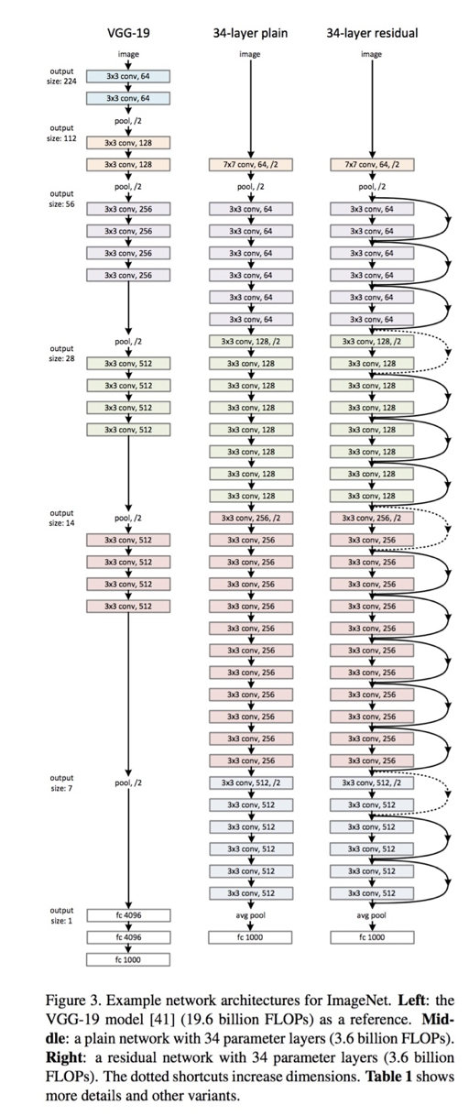
You can see that after starting with a single convolutional layer and Max Pooling, there are 4 similar layers with varying filter sizes – all of them using 3 * 3 convolution operation. Also, after every 2 convolutions, we are bypassing/skipping the layer in between. This is the main concept behind ResNet models. These skipped connections are called ‘identity shortcut connections” and use what is called residual blocks:
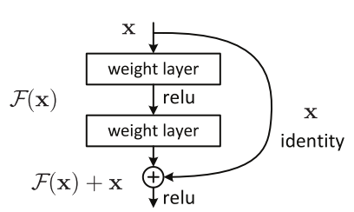
In simple terms, the authors of ResNet propose that fitting a residual mapping is much easier than fitting the actual mapping and thus applying it to all the layers. Another interesting point to note is that the authors of ResNet are of the opinion that the more layers we stack, the model should not perform worse.
This is contrary to what we saw in Inception and is almost similar to VGG16 in the sense that it just stacks layers on top of each other. ResNet changes the underlying mapping.
The ResNet model has many variants, of which the latest is ResNet152. The following is the architecture of the ResNet family in terms of the layers used:
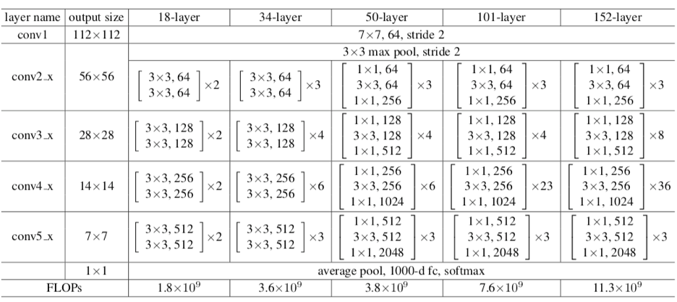
Let us now use ResNet50 on our dataset for image classification model:
Step 1: Data Augmentation and Generators
# Add our data-augmentation parameters to ImageDataGenerator

train_datagen = ImageDataGenerator(rescale = 1./255., rotation_range = 40, width_shift_range = 0.2, height_shift_range = 0.2, shear_range = 0.2, zoom_range = 0.2, horizontal_flip = True)

test_datagen = ImageDataGenerator(rescale = 1.0/255.)

train_generator = train_datagen.flow_from_directory(train_dir, batch_size = 20, class_mode = 'binary', target_size = (224, 224))

validation_generator = test_datagen.flow_from_directory( validation_dir, batch_size = 20, class_mode = 'binary', target_size = (224, 224))
vie
Step 2: Import the base model
from tensorflow.keras.applications import ResNet50

base_model = ResNet50(input_shape=(224, 224,3), include_top=False, weights="imagenet")
Again, we are using only the basic ResNet model, so we will keep the layers frozen and only modify the last layer:

for layer in base_model.layers:
layer.trainable = False
Step 3: Build and Compile the Model
I would like to show you an even shorter code for using the ResNet50 model. We will use this pretrained models for image classification model as a layer in a Sequential model and add a single Fully Connected Layer.
from tensorflow.keras.applications import ResNet50
from tensorflow.python.keras.models import Sequential
from tensorflow.python.keras.layers import Dense, Flatten, GlobalAveragePooling2D

base_model = Sequential()
base_model.add(ResNet50(include_top=False, weights='imagenet', pooling='max'))
base_model.add(Dense(1, activation='sigmoid'))
We compile the image classification model, and this time, let us try the SGD optimizer:
base_model.compile(
optimizer=tf.keras.optimizers.SGD(lr=0.0001),
loss='binary_crossentropy',
metrics=['acc']
)
Step 4: Fitting the model
resnet_history = base_model.fit(
train_generator,
validation_data=validation_generator,
steps_per_epoch=100,
epochs=10
)
The following is the result we get-
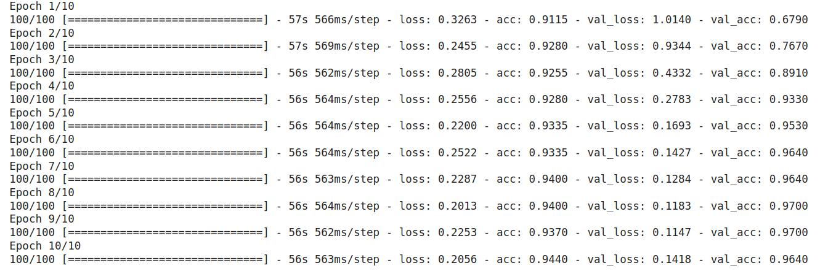
You can see how well it performs on our dataset, making ResNet50 one of the most widely used Pre-trained models. Like VGG, it also has other variations, as seen in the table above. Remarkably, ResNet not only has its own variants, but it also spawned a series of architectures based on ResNet. These include ResNeXt, ResNet as an Ensemble, etc. Additionally, the ResNet50 is among the most popular image classification models out there and achieved a top-5 error rate of around 5%.

EfficientNet
We finally came to the latest model among these four that has caused waves in this domain, and of course, it is from Google. In EfficientNet, the authors propose a new Scaling method called Compound Scaling. The long and short of it is this: The earlier models like ResNet follow the conventional approach of arbitrarily scaling the dimensions and adding more layers.
However, the paper proposes that if we simultaneously scale the dimensions by a fixed amount and do so uniformly, we achieve much better performance. The scaling coefficients can, in fact, be decided by the user.
Though this scaling technique can be used for any CNN-based model, the authors started off with their own baseline model called EfficientNetB0:
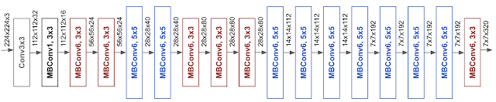
MBConv stands for mobile inverted bottleneck Convolution(similar to MobileNetv2). They also propose the Compound Scaling formula with the following scaling coefficients:
- Depth = 1.20
- Width = 1.10
- Resolution = 1.15
This formula is used to build a family of EfficientNets – EfficientNetB0 to EfficientNetB7 again. The following is a simple graph showing the comparative performance of this family vis-a-vis other popular models:
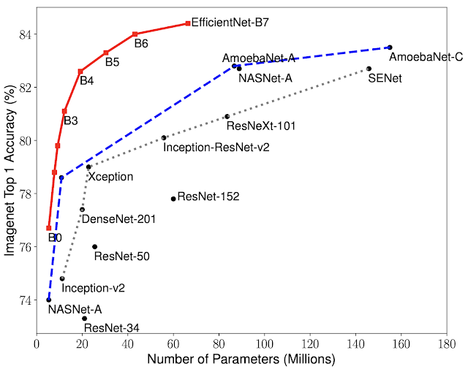
As you can see, even the baseline B0 model starts at a much higher accuracy, which only increases, and that too with fewer parameters. For instance, EfficientB0 has only 5.3 million parameters!
The simplest way to implement EfficientNet is to install it. The rest of the steps are similar to what we have seen above.
Installing EfficientNet
!pip install -U efficientnet
Import it
import efficientnet.keras as efn
Step 1: Image Augmentation
We will use the same image dimensions for VGG16 and ResNet50. By now, you would be familiar with the Augmentation process:
# Add our data-augmentation parameters to ImageDataGenerator
train_datagen = ImageDataGenerator(
rescale=1. / 255.,
rotation_range=40,
width_shift_range=0.2,
height_shift_range=0.2,
shear_range=0.2,
zoom_range=0.2,
horizontal_flip=True
)

test_datagen = ImageDataGenerator(
rescale=1.0 / 255.
)

train_generator = train_datagen.flow_from_directory(
train_dir,
batch_size=20,
class_mode='binary',
target_size=(224, 224)
)

validation_generator = test_datagen.flow_from_directory(
validation_dir,
batch_size=20,
class_mode='binary',
target_size=(224, 224)
)
Step 2: Loading the Base Model
We will use the B0 version of EfficientNet since it is the simplest of the 8. I urge you to experiment with the rest of the models, though do keep in mind that they are becoming increasingly complex, which might not be best suited for a simple binary classification task.
base_model = efn.EfficientNetB0(
input_shape=(224, 224, 3),
include_top=False,
weights='imagenet'
)
Again, let us freeze the layers:
for layer in base_model.layers:
layer.trainable = False
Step 3: Build the Model
Just like Inceptionv3, we will perform these steps at the final layer:
x = base_model.output
x = Flatten()(x)
x = Dense(1024, activation="relu")(x)
x = Dropout(0.5)(x)

# Add a final sigmoid layer with 1 node for classification output
predictions = Dense(1, activation="sigmoid")(x)
model_final = Model(input=base_model.input, output=predictions)
Step 4: Compile and Fit
Let us again use the RMSProp Optimiser, though here, I have introduced a decay parameter:
model_final.compile(
optimizers.rmsprop(lr=0.0001, decay=1e-6),
loss='binary_crossentropy',
metrics=['accuracy']
)
We finally fit the model on our data:
eff_history = model_final.fit_generator(
train_generator,
validation_data=validation_generator,
steps_per_epoch=100,
epochs=10
)
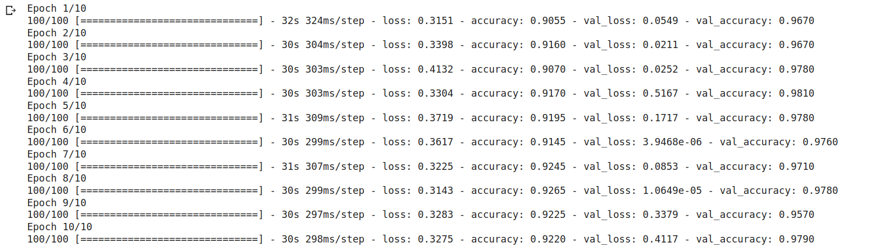
There we go: we achieved a whopping 98% accuracy on our validation set in only 10 epochs. I urge you to try training the larger dataset with EfficientNetB7 and share the results below.
Result
In this article we found the top State-of-the-Art pre-trained models for image classification. Here is a handy table for you to refer to these models and their performance:
